Communications Survey Results
Method: survey monkey, Dec. 2011

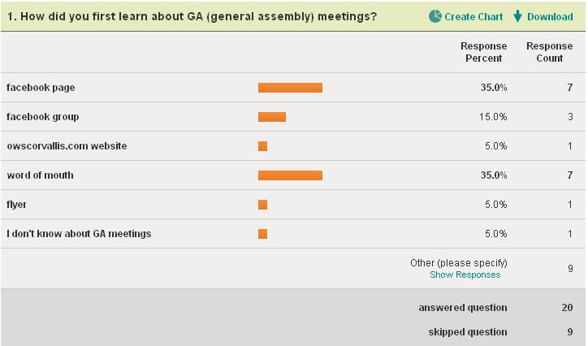

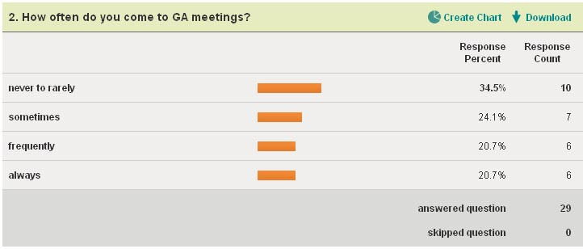

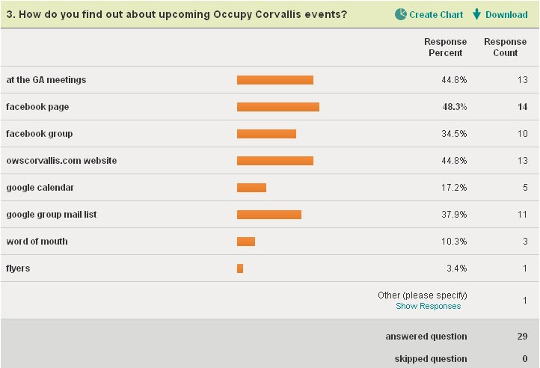

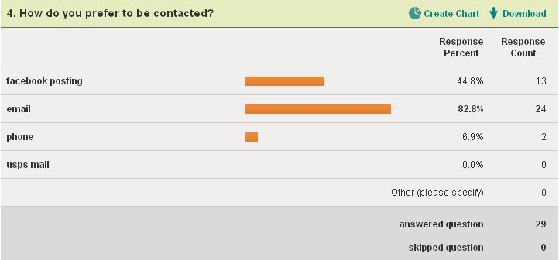

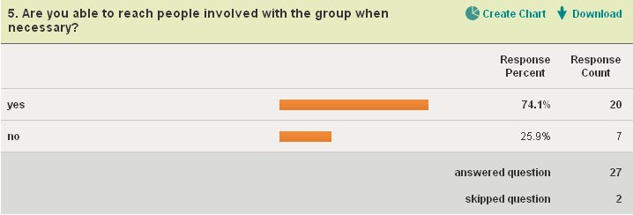

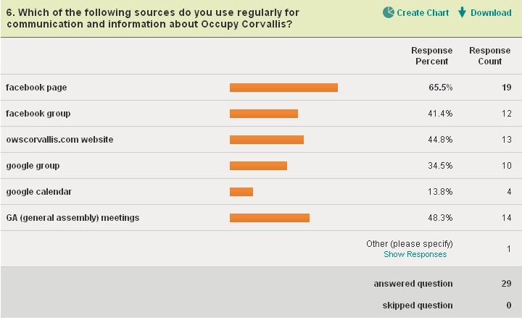

Further comments:

Yes! I am an originator of Occupy Salem. I leaned a lot and would love to share. (see Kris for contact info) thanks for your effors

There are so many emails that go to the whole group, that are actually limited in intent to one or two people. While it's somewhat interesting to learn the personalities of the frequent emailers, it also results in me opening a small percentage of the group emails. I suggest people take the time to write succinctly and voluntarily limit themselves.

Events where critical mass is required could stand being advertised better. Also I've gotten mixed messages about where and especially when GA meetings are held. I won't be around much this winter so don't expect to participate much, but am supportive of what the group is doing, and may participate more later down the line.

I see our evolving website and our FB pages as great sources for information sharing and dialogue. I do see a need to keep updated fliers (with visual impact) in public spaces that provide basic info about meetings and online sites.

We need to guard against forming an "in group" with special jargon, who are on top of what's happening and how to get things done, because that can leave newcomers on the outside. Recognize buzzwords and local processes and define them for everybody when they are used. Encourage the most regular participants to seek out newcomers and help them to orient.

1. Need handouts for people that ask questions when demonstrating at BofA on Mondays. 2. Although I use the google group, I wish people would be more concise, or there was a better medium than that. It has way too many emails every time we say something on it, but I don't know what would be better. I tried to go to the daily digest, but it wouldn't let me, but instead sent me 2 emails by adding my gmail account along with my original email! Very frustrating. :-( 3. We need to find out how to get more people for upcoming demonstrations. i.e. Chris had some great ways she did it for the Funeral of the American Dream, and I'd like us all to know how she does it, along with other people's suggestions. 4. I think our web page is awesome, but don't know why I don't go there more? 5. I wish we could each have a contact sheet for each other's email and phone numbers, but understand the trust and privacy concerns.
think the new website will work well, particularly the forums if set up well. It might be good to have chat or a chat room but not sure how many could contribute. I used IRC relay chat years ago and found it to work well for certain types of communication. the ability to see the main window and yet carry on some side conversations was good as this did not bother the larger group like would happen in a regular GA.

GA meeting should begin with brief introductions of all and an explanation of how the process works so newcomers feel more part of what's happening. 10 minutes should be adequate to do both.

I have not been able to come to as many meetings as I would have liked. So take that into account with my responses. I have never tried to contact anyone (question 5), so you may want to have a 3rd option for of N/A. I like the owscorvallis.com website much better than facebook for scheduling, official news, and event news. The schedule and update boxes at first glance look like ads or something to ignore. I'm not sure if they can be changed but a layout or style change could to make them feel more a part of the site.

I feel rather overwhelmed by the sheer number and volume of e-mail messages that come across the Google group. I cannot keep up with all of it, and my e-mail box is full of hundreds of unread messages. I understand there is a digest function, which should be easy enough to figure out.

The web site that AmberLynn is developing looks like it will evolve into the most effective communication/ideas/outreach platform for Occupy Corvallis. I think the Occupy Community page will remain useful for general community contact and information. The Google Group can probably be abandoned at some point.

I almost got off the email list because of quantity of mostly not important private conversations but it has gotten better. Thanks for your good works.

post major events to facebook group

I do not think that having too many ways of communicating is a problem. Just because one method reaches the most people does not mean there aren't other way that would work for other people. Ways of communicating like meetup.com and twitter weren't even on your list. I know there is a contingent that uses meetup, and I've seen a few tweets of people searching for, but not finding (because they're using twitter) us. Each serve their own purpose, and we want to be careful to be as inclusive as possible and avoid marginalizing people as best we can.

